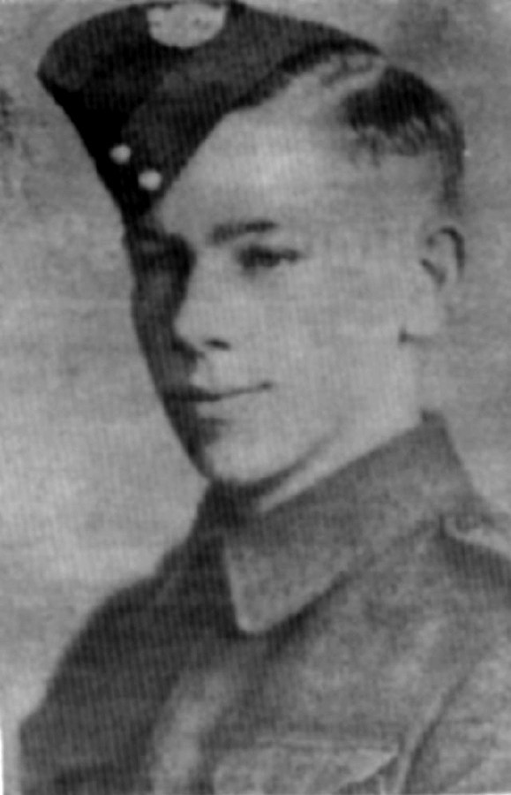
Rees, H.C., Pte.
K42999 Private Henry Cavendish Rees of the Princess Patricia’s Canadian Light Infantry was killed in action on 19 September 1944 and is buried at the Coriano Ridge War Cemetery, Italy. Harry as he was called was born in Winnipeg on 17 December 1923. While still an infant his family moved from East Kildonan to Sapllumcheen, British Columbia. He was raised on the farm in the Knob Hill area. Henry left school at the age of fourteen having completed grade eight. He had to leave in order to work the farm with his older brother. His brother Nigel bought out the farm next to his and he and Harry became partners in the farm. During the offseason, Harry worked in the logging industry. His ambition was to become a diesel engineer. He was also a hunter and fisherman as well as enjoying riding. Harry Rees joined the Canadian Army in Vernon, British Columbia on 12 September 1940 and was taken on strength to the 1st Battalion, Rocky Mountain Rangers in Kamloops, British Columbia. The unit moved to New Westminster, British Columbia where he was admitted to the hospital with influenza from 27 October to 2 November 1940. Pte Rees went on to serve with his regiment in Prince Rupert and in Nanaimo in 1941. He was on harvest leave at his farm from 18 September to 16 October 1941 and returned to the Rocky Mountain Rangers now in New Westminster. On return he requested permission to marry Winnifred Ruby Chanda of Armstrong. The couple were married at the St. Alban’s Church in New Westminster on 29 November 1941. On 21 March 1942 he qualified as a wheeled driver. His regiment was then training at Colwood Camp, British Columbia. Due to his mechanical ability he was sent on a driver track course held at the S11 Advanced Driver and Maintenance School in Woodstock, Ontario from 24 July to 21 August 1942. While at the school he also qualified as a motorcycle driver. Pte Rees returned to his unit in Colwood Camp. His daughter Diane Sharon was born on 12 October 1942. The following day he was absent without leave, was charged and awarded three days Confinement to Barracks. He deployed overseas in February 1943 arriving in England on 13 February and was posted to the 1st Canadian Infantry Reinforcement Unit. Pte Rees joined the Princess Patricia’s Canadian Light Infantry in England on 21 May 1943 as they were preparing for amphibious operations. He sailed with the regiment on Operation Husky landing on beaches of Sicily on 10 July 1943. He fought with the Patricia’s advancing north through Grammichele, Piazza Armerina, and Valguarnera. The Patricias fought in the taking of the town of Leonforte on 23 July 1943. Pte Rees fought along the highway to Agira and during the Battle of Agira. He also participated in the assault on Monte Seggio. On 7 August he was evacuated by No.9 Canadian Field Ambulance and admitted to hospital the following day. A day later he rejoined the Patricias. The regiment was in a rest camp awaiting the amphibious assault on mainland Italy. Pte Rees fought in the northern advance to Potenza after crossing the Straits of Messina. He continued the fight during the advance to Campobasso, the crossing of the Moro River, the fight at Villa Rogatti, the Battle of Ortona, the defensive operations near Ortona and the defensive operation near Crecchio. While preparing for the assault on the Hitler Line he was evacuated on 17 April 1944 to No.14 Canadian General Hospital and returned to the regiment on 26 June 1944 after the breaching of the Hitler Line. Pte Rees fought with the PPCLI during operations near Florence, the assault on the Gothic Line and the advance to San Fortunato. The attack on San Fortunato Ridge began on the night of 19 September 1944. At this time the Patricias where located on the enemy side of the Auso River and tasked with securing the start line for assaulting battalions against the first objective; the town. The PPCLI came under artillery fire during the night and Pte Rees was killed during the bombardment. He was buried in a temporary grave at Riccione and after the war was reburied at the war cemetery. Pte Rees was awarded the 1939-45 Star, Italy Star, War Medal and the Canadian Volunteer Service Medal with Clasp. Pte Rees was the son of Charles Gerald and Dorothy Winifred Rees of Armstrong, British Columbia. He was the husband of Winnifred Ruby Rees of Salmon Arm, British Columbia and the father of Diane Sharon Rees. Pte Rees was the brother of Gunner John Charles Greenhill Rees who was serving overseas in the RCA, Nigel Tudor Rees of Knob Hill, Private Sheila St. Barbe Rees who was serving at Shilo, Manitoba in the CWAC and Eve Churchill Rees of Armstrong, British Columbia. His brother Gunner Bruce Dixie Rees who was serving in the RCA in Dartmouth, Nova Scotia died on active service on 14 May 1940. Gnr Bruce Rees accidentally drowned when he was swimming at Goose Lake.
Memorial Mountain, British Columbia (maps sheet 82L/6) 50° 25’ 37”N 119° 06’ 56”W, located southeast of Armstrong was named in honour those killed in action or died on active service from the Armstrong and Spallumcheen on 11 November 1998.

