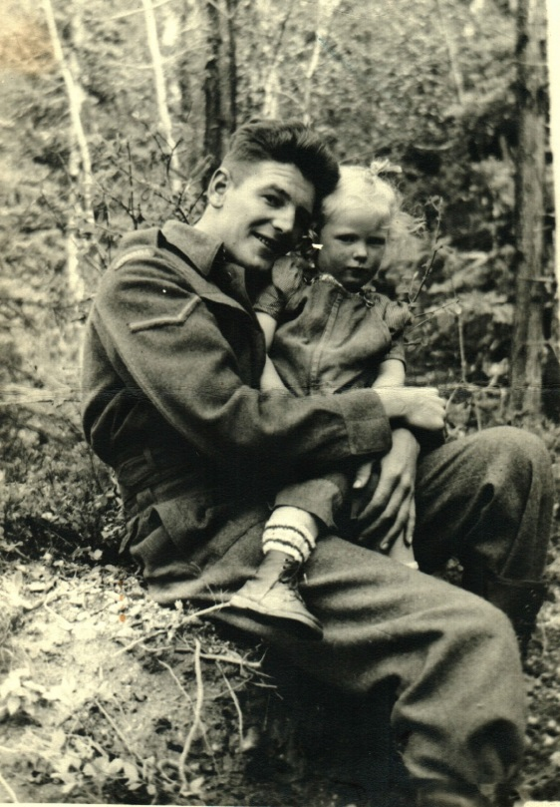**Youngren, J.A., Pte.**

K1759 Private Julius Allan Youngren of the Princess Patricia’s Canadian Light Infantry was killed in action on 20 October 1944 and is buried at the Cesena War Cemetery, Italy. Julius was born on 26 September 1919 in Kingcome Inlet, British Columbia. He was raised in Vancouver and Chilliwack, British Columbia. Julius Youngren attended school in Chilliwack and left school after finishing grade six at the age of thirteen. He liked to play baseball and football as well as going hunting in his spare time. Julius was interested in gas engines as a hobby. He took home study courses in Gas and Diesel mechanics. His father was a prospector in the Cariboo country of British Columbia and Julius followed me in this profession working alongside his father as a placer miner. After four years he took a job as a hard rock miner followed by working in Powell River paper mill as a grinder operator. He also worked as a heavy equipment operator and a gas and diesel engineer. Prior to enlistment he was employed as a logger for the Jack Anderson Logging Company out of Stuart Island, British Columbia. Julius married his wife Marjorie Bevan in Williams Lake, British Columbia on 21 September 1939. He was living in Keithley Creek, British Columbia when he joined the Canadian Army in Vancouver, British Columbia on 4 January 1944 and was taken on strength to No.131 Canadian Army Basic Training Centre in Camrose, Alberta. After completing basic in early March he went on to his infantry course held at A16 Canadian Infantry Training Centre in Calgary, Alberta on 26 March 1944. From 10 to 18 April 1944 he was admitted to the Colonel Belcher Hospital. He was promoted to Lance Corporal on 12 April 1944. In order to go overseas he relinquished his rank and reverted back to Private. Pte Youngren deployed overseas arriving in England on 24 June 1944 and was posted to the 1st Canadian Infantry Reinforcement Unit. The next month he was on route to Italy arriving in theatre on 29 July 1944. Pte Youngren joined the Patricias in the field on 5 September 1944 after the assault on the Gothic Line. After advancing up the coast, their next objective was the crossing of the Savio River. The PPCLI conducted a river crossing under contact with the enemy on 20 October 1944. All support weapons closed up on the friendly side ready to engage the moment the two lead companies, Alpha and Delta crossed the river. During the crossing the Germans let loose with their defensive fire plan and ‘D’ Company was pinned down at the obstacle. Elements of Alpha Company managed to get across with very little opposition after traversing 600 yards of a minefield. The small force prepared to move up the ravine sending a detachment forward to recce one of which was killed in the process. Alpha Company moved forward and attacked a house after a serious fire fight. At this point a message to hold was put in place. The Company held their positions for thirty hours under machine gun and indirect fire. During this fight Pte Youngren was killed in action. Pte Youngren was awarded the 1939-45 Star, Italy Star, War Medal and the Canadian Volunteer Service Medal with Clasp. He was the son of Arthur Lee and Aleen Grace. His father was in the Cariboo while his mother lived in Dayville, Oregon, USA. Pte Youngren was the husband of Marjorie Bevan Youngren and the father of Julene Bevan Youngren of Keithley Creek, British Columbia. He was the brother of Fred Youngren of the Cariboo, Mrs Joy McPhee of Courtney, British Columbia and Rose Youngren of Dayville, Oregon, USA.

**Mount Youngren, British Columbia** (map sheet 93A/15) 52° 54’ 16”N 120° 46’ 06”W, located in the Cariboo Mountains Provincial Park, was named in his honour on 1 June 1966